**Heart Experiment**

**You Need:**

1. Small Jar
2. 2 Bendy Straws
3. Balloon
4. Tape
5. Water
6. Red Food Coloring

### ****The Set Up:****

Fill your jar or glass halfway with water and add some red food coloring.

Take your balloon and cut the neck of it off. Take that top part, stretch it out a bit, and put it over the top of the jar. Save the neck part as well.

Pro tip: Have extra balloons. I managed to rip my first one.

Take a sharp toothpick and poke a hole in the top of the balloon once towards one side of the jar. Make a second hole about an inch away from the first. **Try to make the holes as small as you can.

ADULT ONLY: Instead of toothpicks use scissors or a knife to make the small holes. **Try to make the holes as small as you can.

Take your straws and push one through each hole with the bendy part sticking out the top. You might have to push hard, but they should pop through.

Take the neck of the balloon that you set aside and use it to cover the opening of one straw sticking out of the cup.

Your pumping heart model is ready to get that blood flowing!

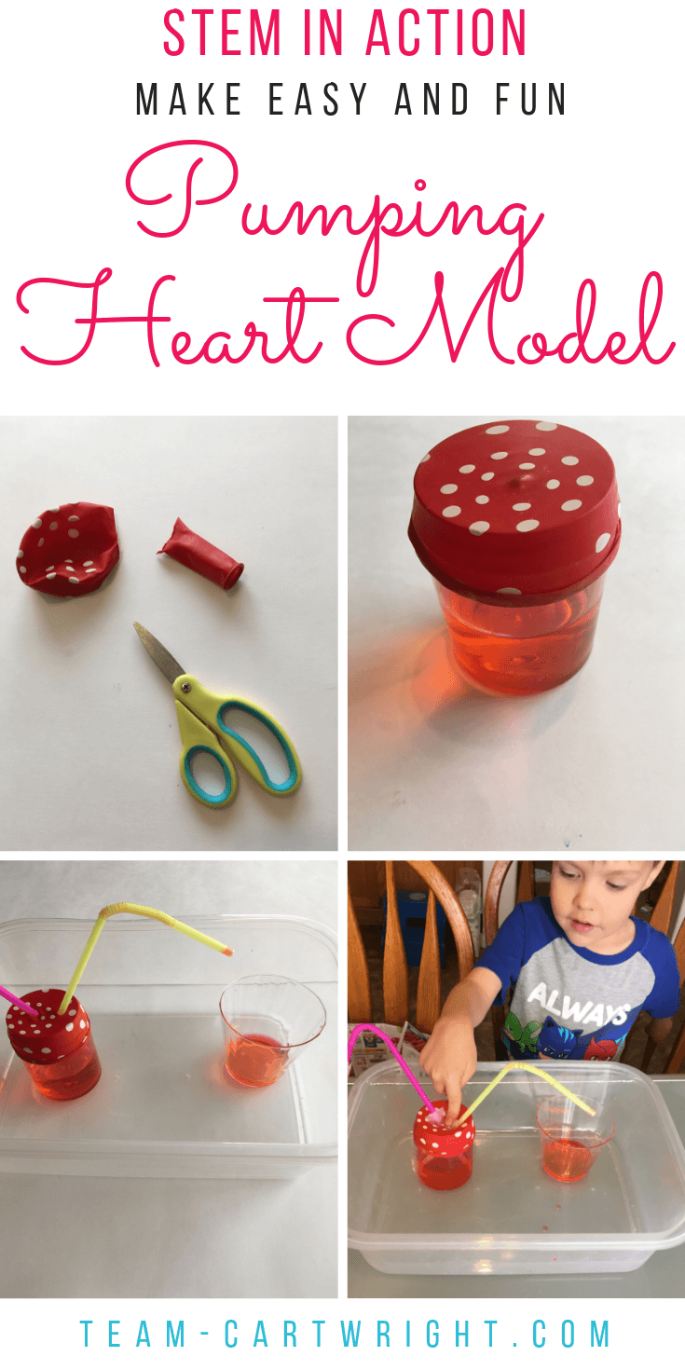 

1. Cut the balloon and poke 2 holes in the top 2. Add water w/ red food coloring (jar ½ full)

 

3. Place straws through the holes don’t rip the balloon 4. Place jar in container.

NOTE: NO need for second cup