 NAME: ________________________________

DATE: ________________________________

**LESSON 2 ALL ABOUT SEEDS**

1. Define the word seed.

2. Label the parts of the seed below and describe them.

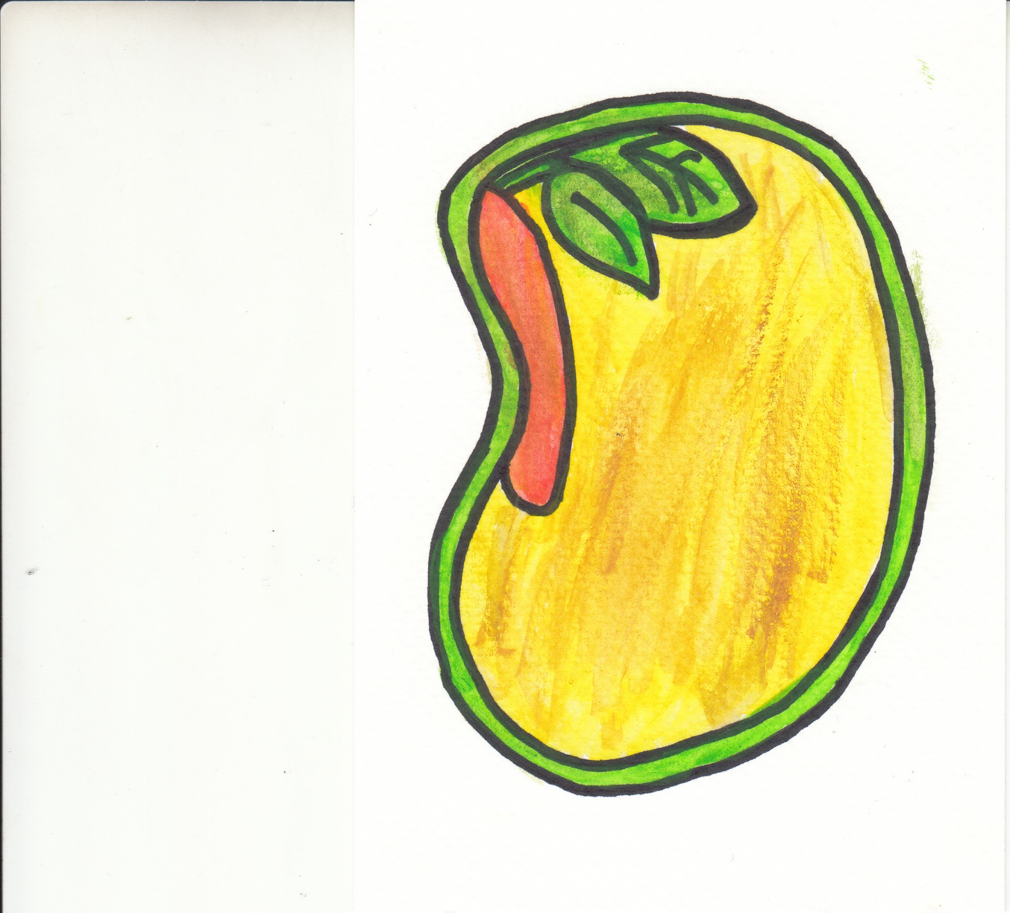

In His hand is the life of every living creature and the breath of all mankind.

-Job 12:10

**REMEMBER!**

d.

c.

b.

a.