 NAME: ________________________________

DATE: ________________________________

**LESSON 3 ALL ABOUT FLOWERS**

1. Define the word flower.

Label the parts of the flower below and describe them.

1.

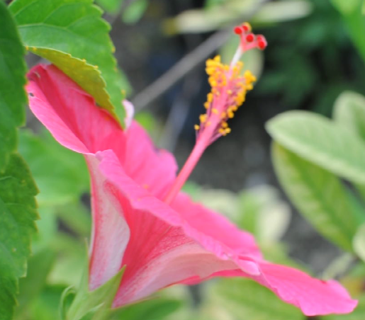

In His hand is the life of every living creature and the breath of all mankind.

-Job 12:10

4.

3.

2.

**REMEMBER!**