 NAME: ________________________________

DATE: ________________________________

**ALL ABOUT CORALS**

1. Define the word corals
2. Define coral reef
3. Define ecosystem

Label the parts of the corals below and describe them.

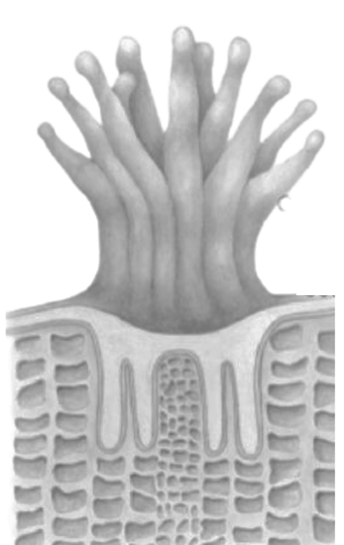

1.

4.

3.

2.

In His hand is the life of every living creature and the breath of all mankind.

-Job 12:10

**REMEMBER!**

In His hand is the life of every living creature and the breath of all mankind.

-Job 12:10

**REMEMBER!**